Brazilian E-Commerce Business Intelligence Insights Part 1: Outlining the Business Question

Image URL: https://www.iru.org/news-resources/newsroom/wheels-progress-road-transport-and-brazils-economic-and-social-pulse
Business Question: The analyst is working for a Brazilian E-Commerce company and has been provided a data set from which to draw business intelligence insights. The main business question is to determine in what areas are we receiving the greatest number of orders and payments? In what areas are we receiving the largest number of customers and which customers are responsible for the greatest number of orders and payments? We would also like to know the rate of conversion of orders? Any other important business question of note. Lastly, we would like to create some visualizations using the queries with the desired business intelligence insights onto a Tableau dashboard with recommendations of findings. The source data for this business question has been provided by Kaggle and is as follows below:
https://www.kaggle.com/datasets/olistbr/brazilian-ecommerce
We will begin by architecting a schema using Lucidchart for the purpose of understanding the relationship between entities from within the database. The schema is as follows:
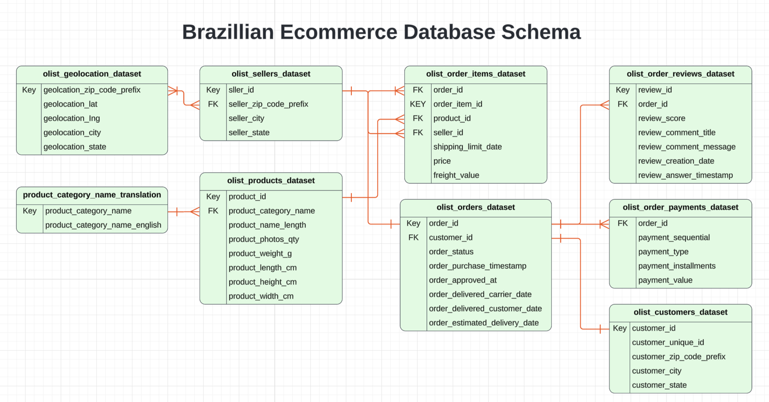
Explanation: As illustrated in the relational diagram above, there happens to be 9 entities from within the schema. They are as follows:
- olist_geolocation_dataset (Geo Location)
- olist_sellers_dataset (Sellers)
- product_category_name_translation (Translations)
- olist_products_dataset (Products)
- olist_order_items_dataset (Orders Items)
- olist_orders_dataset (Orders)
- olist_order_reviews_dataset (Reviews)
- olist_order_payments_dataset (Payments)
- olist_customers_dataset (Customers)
We will begin by looking at the “Orders” table. As we are working for an E-Commerce company, this table was created using an order tracking system with a unique order id. As it is possible for a particular order to come with multiple items, this entity has a one-to-many relationship with the “Orders Items” table. The “Orders Items” table also has a many-to-one relationship with “Products” because one product description can pertain to multiple “Order Items” from within the dataset. Likewise, a particular seller can pertain to multiple “Order Items”; thus “Order Items” also has a many-to-one relationship with the “Sellers” table.
In contrast, the “Orders” table has a direct one-to-one relationship with the “Customers” table, as it is assumed that a particular customer with a unique ID was responsible for making a given order. However, a customer may use financing options for a particular order, bounce and miss a payment, or return an item and receive a refund. Therefore, the “Payments” table has a many-to-one relationship with the “Orders” dataset. The “Orders” table also has a one-to-many relationship with the “Reviews” table, as there can be multiple reviews for a particular order on online platforms. Given the high rate of many-to-one connections with other entities, the “Orders Items” table has the largest number of entries out of all other entities from within the schema.
Going to the opposite end of the schema, the “Translations” table has a one-to-many relationship with the “Products” dataset because it is a reference table that classifies different products by grouping them from within many of the same categories. Lastly, the “Geo Location” table has a many-to-many relationship with the “Sellers” table because there can be multiple sellers that operate across multiple geographic locations.
After constructing and analyzing the schema, the analyst can now load the database onto the SQL IDE of choice. In this case, we will be downloading the data directly onto our laptop and then upload the data into PGADMIN 4, which will be the IDE where we will be running our queries. PGADMIN 4 is the IDE of choice because we are old school and do not want to pay for cloud data warehouse storage and computing. However, this project can be done using an IDE in the cloud by uploading the data into a data warehouse and then connecting it to a cloud SQL server of choice (Big Query, Redshift, Snowflake, Databricks, etc.).
NOTE: The working directory needs to be specified every time a create table statement is run into PGADMIN4. To accomplish this, open the computer terminal and paste the following code and run it prior to running the SQL codes separately within PGADMIN4.
Open the CMD terminal onto your local computer and paste the code prior to running an individual "Create Table" statement in PGADMIN4 (specified in the subsequent code blocks). This process must be repeated 9 times for each entity from within the schema. The only thing that will need to be revised are the specifications for the local working directory, along with the specific table name within the olist datasets stored locally for which the user would like to create an individual table within PGADMIN4.
------------------------------------------------------------------------------------------------------------------
mkdir -p /tmp/olist_data
cp "/Users/danielhom/Desktop/Learning Materials/Assignment #2-Brazillian E-Commerce/[TABLE NAME].csv" /tmp/olist_data/
chmod 644 /tmp/olist_data/[TABLE NAME].csv
---------------------------------------- Create “Customers” Table ----------------------------------------
DROP TABLE IF EXISTS "Customers";
CREATE TABLE "Customers" (
customer_id VARCHAR(50) NOT NULL,
customer_unique_id VARCHAR(50) NOT NULL,
customer_zip_code_prefix VARCHAR(10) NOT NULL,
customer_city VARCHAR(100) NOT NULL,
customer_state VARCHAR(10) NOT NULL,
PRIMARY KEY (customer_id)
);
COPY public."Customers"(customer_id, customer_unique_id, customer_zip_code_prefix, customer_city, customer_state)
FROM '/tmp/olist_data/olist_customers_dataset.csv'
WITH (FORMAT csv, DELIMITER ',', QUOTE '"', ESCAPE '"', HEADER);
CREATE INDEX idx_customer_unique_id ON "Customers" (customer_unique_id);
------------------------------------ Create “Geo Location” Table -----------------------------------------
DROP TABLE IF EXISTS "Geo Location";
CREATE TABLE "Geo Location" (
geolocation_id SERIAL PRIMARY KEY,
geolocation_zip_code_prefix VARCHAR(10) NOT NULL,
geolocation_lat NUMERIC(15, 10) NOT NULL,
geolocation_lng NUMERIC(15, 10) NOT NULL,
geolocation_city VARCHAR(100) NOT NULL,
geolocation_state VARCHAR(10) NOT NULL
);
COPY public."Geo Location"(geolocation_zip_code_prefix, geolocation_lat, geolocation_lng, geolocation_city, geolocation_state)
FROM '/tmp/olist_data/olist_geolocation_dataset.csv'
WITH (FORMAT csv, DELIMITER ',', QUOTE '"', ESCAPE '"', HEADER);
------------------------------------ Create “Orders Items” Table ---------------------------------------
DROP TABLE IF EXISTS "Orders Items";
CREATE TABLE "Orders Items" (
order_id VARCHAR(50) NOT NULL,
order_item_id INTEGER NOT NULL,
product_id VARCHAR(50) NOT NULL,
seller_id VARCHAR(50) NOT NULL,
shipping_limit_date TIMESTAMP NOT NULL,
price NUMERIC(10, 2) NOT NULL,
freight_value NUMERIC(10, 2) NOT NULL,
PRIMARY KEY (order_id, order_item_id)
);
COPY public."Orders Items"(order_id, order_item_id, product_id, seller_id, shipping_limit_date, price, freight_value)
FROM '/tmp/olist_data/olist_order_items_dataset.csv'
WITH (FORMAT csv, DELIMITER ',', QUOTE '"', ESCAPE '"', HEADER);

-- Alter the table to get the short date instead
ALTER TABLE "Orders Items"
ALTER COLUMN shipping_limit_date TYPE DATE
USING shipping_limit_date::DATE;
--------------------------------------- Create” Payments” Table-------------------------------------------
DROP TABLE IF EXISTS "Payments";
CREATE TABLE "Payments" (
order_id VARCHAR(50) NOT NULL,
payment_sequential INTEGER NOT NULL,
payment_type VARCHAR(20) NOT NULL,
payment_installments INTEGER NOT NULL,
payment_value NUMERIC(10, 2) NOT NULL,
PRIMARY KEY (order_id, payment_sequential)
);
COPY public."Payments"(order_id, payment_sequential, payment_type, payment_installments, payment_value)
FROM '/tmp/olist_data/olist_order_payments_dataset.csv'
WITH (FORMAT csv, DELIMITER ',', QUOTE '"', ESCAPE '"', HEADER);
--------------------------------------- Create” Reviews” Table--------------------------------------------
DROP TABLE IF EXISTS "Reviews";
CREATE TABLE "Reviews" (
review_id VARCHAR(50) NOT NULL,
order_id VARCHAR(50) NOT NULL,
review_score INTEGER NOT NULL,
review_comment_title VARCHAR(255),
review_comment_message TEXT,
review_creation_date TIMESTAMP NOT NULL,
review_answer_timestamp TIMESTAMP NOT NULL,
PRIMARY KEY (review_id, order_id)
);
COPY public."Reviews"(review_id, order_id, review_score, review_comment_title, review_comment_message, review_creation_date, review_answer_timestamp)
FROM '/tmp/olist_data/olist_order_reviews_dataset.csv'
WITH (FORMAT csv, DELIMITER ',', QUOTE '"', ESCAPE '"', HEADER);
-- Alter the table to get the short date instead
ALTER TABLE "Reviews"
ALTER COLUMN review_creation_date TYPE DATE
USING review_creation_date::DATE;
ALTER TABLE "Reviews"
ALTER COLUMN review_answer_timestamp TYPE DATE
USING review_answer_timestamp::DATE;
------------------------------------------ Create” Orders” Table--------------------------------------------
DROP TABLE IF EXISTS "Orders";
CREATE TABLE "Orders" (
order_id VARCHAR(50) NOT NULL,
customer_id VARCHAR(50) NOT NULL,
order_status VARCHAR(20) NOT NULL,
order_purchase_timestamp TIMESTAMP NOT NULL,
order_approved_at TIMESTAMP,
order_delivered_carrier_date TIMESTAMP,
order_delivered_customer_date TIMESTAMP,
order_estimated_delivery_date TIMESTAMP NOT NULL,
PRIMARY KEY (order_id)
);
COPY public."Orders"(order_id, customer_id, order_status, order_purchase_timestamp, order_approved_at, order_delivered_carrier_date, order_delivered_customer_date, order_estimated_delivery_date)
FROM '/tmp/olist_data/olist_orders_dataset.csv'
WITH (FORMAT csv, DELIMITER ',', QUOTE '"', ESCAPE '"', HEADER);
-- Alter the table to get the short date instead
ALTER TABLE "Orders"
ALTER COLUMN order_purchase_timestamp TYPE DATE
USING order_purchase_timestamp::DATE;
ALTER TABLE "Orders"
ALTER COLUMN order_approved_at TYPE DATE
USING order_approved_at::DATE;
ALTER TABLE "Orders"
ALTER COLUMN order_delivered_carrier_date TYPE DATE
USING order_delivered_carrier_date::DATE;
ALTER TABLE "Orders"
ALTER COLUMN order_delivered_customer_date TYPE DATE
USING order_delivered_customer_date::DATE;
ALTER TABLE "Orders"
ALTER COLUMN order_estimated_delivery_date TYPE DATE
USING order_estimated_delivery_date::DATE;
---------------------------------------- Create” Products” Table------------------------------------------
DROP TABLE IF EXISTS "Products";
CREATE TABLE "Products" (
product_id VARCHAR(50) NOT NULL,
product_category_name VARCHAR(100),
product_name_lenght INTEGER,
product_description_lenght INTEGER,
product_photos_qty INTEGER,
product_weight_g INTEGER,
product_length_cm INTEGER,
product_height_cm INTEGER,
product_width_cm INTEGER,
PRIMARY KEY (product_id)
);
COPY public."Products"(product_id, product_category_name, product_name_lenght, product_description_lenght, product_photos_qty, product_weight_g, product_length_cm, product_height_cm, product_width_cm)
FROM '/tmp/olist_data/olist_products_dataset.csv'
WITH (FORMAT csv, DELIMITER ',', QUOTE '"', ESCAPE '"', HEADER);
-- Alter column header for more accurate spelling
ALTER TABLE "Products"
RENAME COLUMN product_name_lenght TO product_name_length;
------------------------------------------ Create” Sellers” Table--------------------------------------------
DROP TABLE IF EXISTS "Sellers";
CREATE TABLE "Sellers" (
seller_id VARCHAR(50) NOT NULL,
seller_zip_code_prefix VARCHAR(10) NOT NULL,
seller_city VARCHAR(100) NOT NULL,
seller_state VARCHAR(10) NOT NULL,
PRIMARY KEY (seller_id)
);
COPY public."Sellers"(seller_id, seller_zip_code_prefix, seller_city, seller_state)
FROM '/tmp/olist_data/olist_sellers_dataset.csv'
WITH (FORMAT csv, DELIMITER ',', QUOTE '"', ESCAPE '"', HEADER);
-------------------------------------- Create” Translations” Table-----------------------------------------
DROP TABLE IF EXISTS "Translations";
CREATE TABLE "Translations" (
product_category_name VARCHAR(100) NOT NULL,
product_category_name_english VARCHAR(100) NOT NULL,
PRIMARY KEY (product_category_name)
);
COPY public."Translations"(product_category_name, product_category_name_english)
FROM '/tmp/olist_data/product_category_name_translation.csv'
WITH (FORMAT csv, DELIMITER ',', QUOTE '"', ESCAPE '"', HEADER);
Conclusion: After we have run each code in PG Admin4 for table creation, we can now run a series of queries for the purpose of answering some of the specific business questions outlined at the beginning of the article. This process will be mentioned in a subsequent article to be written later. Hopefully, this demonstration provided insight as to how database schemas and table creation statements work, along with how they translate to thinking about specific business questions. Looking forward to running SQL queries and presenting the insights in the next article :)

Brazilian E-Commerce Business Intelligence Insights Part 2: Asking Key Business Questions for the Brazilian Ecommerce Dataset

Image URL: https://americasmi.com/insights/brazil-ecommerce-market-data/
Review: We are currently working for a Brazilian E-Commerce company and have been provided a data base of information from which to draw key insights. After outlining the business problem, we created a relational database schema using Lucidchart. We then used the schema as a template for uploading each table from within the database into PGADMIN4. Now that our database has been established, we can run a couple of queries to conduct business intelligence. In the final article of this series, we will use Tableau to create a dashboard onto the query results for presentation of insights into this business question. The link to the Kaggle data is located below:
https://www.kaggle.com/datasets/olistbr/brazilian-ecommerce
Additionally, the GitHub link to the repository storing query results is here.
The first business question we would like to know, is the geographic and customer information for all customers, with the data being arranged in descending order for immediate presentation of the largest customers, as measured by number of items ordered from within the first couple of entries of the query output. The code used to achieve this is as follows below:
WITH orders_totals AS (
SELECT
c.customer_unique_id,
SUM(oi.order_item_id) AS totals
FROM "Orders Items" oi
JOIN "Orders" o ON oi.order_id = o.order_id AND o.order_status = 'delivered'
JOIN "Customers" c ON o.customer_id = c.customer_id
GROUP BY c.customer_unique_id
),

customer_info AS (
SELECT DISTINCT ON (c.customer_unique_id)
c.customer_id,
c.customer_unique_id,
c.customer_zip_code_prefix,
c.customer_city,
c.customer_state
FROM "Customers" c
JOIN orders_totals ot ON ot.customer_unique_id = c.customer_unique_id
),

geo AS (
SELECT DISTINCT ON (g.geolocation_zip_code_prefix)
g.geolocation_zip_code_prefix,
g.geolocation_lat,
g.geolocation_lng
FROM "Geo Location" g
JOIN customer_info ci ON ci.customer_zip_code_prefix = g.geolocation_zip_code_prefix
)
SELECT
ci.customer_id,
ot.customer_unique_id,
ci.customer_zip_code_prefix,
ci.customer_city,
ci.customer_state,
ot.totals AS number_of_items_ordered,
g.geolocation_lat,
g.geolocation_lng,
ROW_NUMBER() OVER(ORDER BY ot.totals DESC) AS customer_rank
FROM orders_totals ot
LEFT JOIN customer_info ci ON ot.customer_unique_id = ci.customer_unique_id
LEFT JOIN geo g ON ci.customer_zip_code_prefix = g.geolocation_zip_code_prefix
ORDER BY ot.totals DESC;

Query Output:
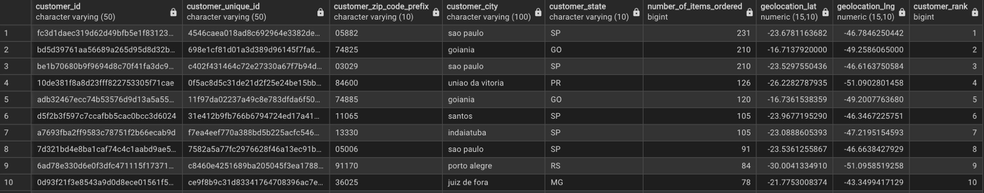
The query output includes both customer_id and customer_unique_id. customer_id is the key linking to the "Orders" table, with each order tied to a unique customer_id — giving "Orders" and "Customers" a one-to-one relationship, since each order belongs to one customer. In contrast, customer_unique_id identifies the actual person, independent of any single order.
Having two keys in "Customers" can seem redundant from an analyst's perspective, adding an extra layer to the relationship between the two tables. However, from a business perspective, it likely reflects how the "Customers" table was assembled — probably compiled from multiple data sources as the e-commerce company built out this entity.
Geographic fields (zip code, city, state, lat/lng) were included to support mapping customer concentration by Brazilian state (26 states plus the Federal District) for the purpose of front-end BI analysis. However, based upon the first 10 entries of the output, it is clear that a large percentage of top customers tend to reside in Sao Paolo (SP), as this is the largest, wealthiest, and most populous state in Brazil. To further our analysis of customers, we also would like to look at the “Payments” table, to determine whether the top customers by number of orders aligns with the top number of customers by dollar value of payments. The query used for providing this insight is located here:
WITH cp AS (
SELECT
o.customer_id,
SUM(p.payment_value) AS total_spend
FROM "Payments" p
JOIN "Orders" o
ON p.order_id = o.order_id
AND o.order_status = 'delivered'
GROUP BY o.customer_id
),

ci AS (
SELECT
cp.customer_id,
c.customer_zip_code_prefix,
c.customer_city,
c.customer_state,
cp.total_spend
FROM cp
LEFT JOIN "Customers" c
ON cp.customer_id = c.customer_id
),

geo AS (
SELECT DISTINCT ON (gl.geolocation_zip_code_prefix)
gl.geolocation_zip_code_prefix,
gl.geolocation_state,
gl.geolocation_lat,
gl.geolocation_lng
FROM "Geo Location" gl
WHERE gl.geolocation_zip_code_prefix IN (
SELECT DISTINCT customer_zip_code_prefix FROM ci
)
ORDER BY gl.geolocation_zip_code_prefix, gl.geolocation_id
),
final_table AS (SELECT
ci.customer_id,
ci.customer_zip_code_prefix,
ci.customer_city,
ci.customer_state,
g.geolocation_state,
ci.total_spend,
g.geolocation_lat,
g.geolocation_lng
FROM ci
LEFT JOIN geo g
ON ci.customer_zip_code_prefix = g.geolocation_zip_code_prefix
ORDER BY ci.total_spend DESC)
SELECT * FROM final_table;
Results:
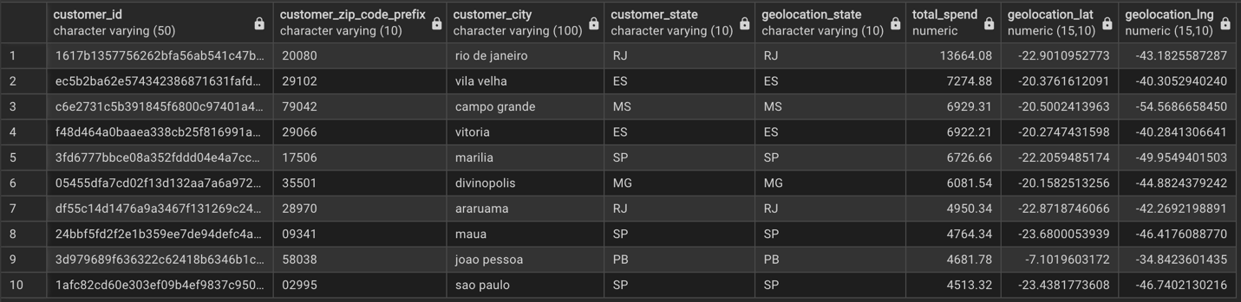
As we can see, there is not a consistent relationship between the top customers as measured by total number of orders and the top customers as measured by total spend. A possible inference from the two queries, is that in Brazilian states outside of Sao Paolo, there are more customers who make larger orders as measured by dollar value, even though the overall total number of orders is less. Whereas, in Sao Paulo, there are more customers who make a high volume of orders, but with a lower dollar amount per order (i.e. lower margin but higher volume in Sao Paulo). As Sao Paulo is probably a more established market for the e-commerce business, it might make more sense to find a way to expand sales to other states, to increase the volume of larger sales. Next, let’s compile a listing for the top sellers as measured by number of items ordered, along with seller and geographic information. The code used for producing the results is here:
WITH sellers_orders AS (
SELECT
oi.seller_id,
SUM(oi.order_item_id) AS number_successful_orders_items
FROM "Orders Items" oi
JOIN "Orders" o ON oi.order_id = o.order_id AND o.order_status = 'delivered'
GROUP BY oi.seller_id
),
consolidated_sellers AS (
SELECT
so.seller_id,
s.seller_zip_code_prefix,
s.seller_city,
s.seller_state,
so.number_successful_orders_items,
MAX(gl.geolocation_lat) AS geolocation_lat,
MAX(gl.geolocation_lng) AS geolocation_lng
FROM sellers_orders so
LEFT JOIN "Sellers" s ON so.seller_id = s.seller_id
LEFT JOIN "Geo Location" gl ON s.seller_zip_code_prefix = gl.geolocation_zip_code_prefix
GROUP BY
so.seller_id,
s.seller_zip_code_prefix,
s.seller_city,
s.seller_state,
so.number_successful_orders_items
)
SELECT
*,
ROW_NUMBER() OVER (ORDER BY number_successful_orders_items DESC) AS seller_rank
FROM consolidated_sellers;
Query Output:
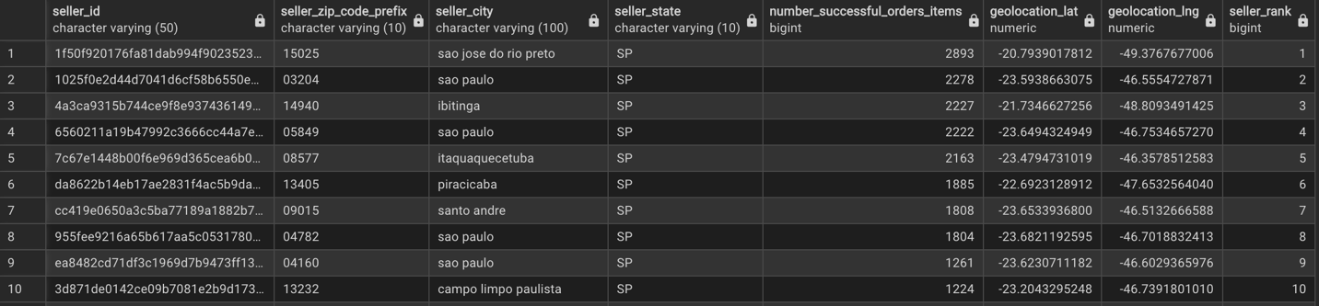
As with the output for the query looking at top customers by number of orders, most of the top sellers also happen to come from Sao Paolo, indicating a high volume of business activity from within this state. Next, we want to look at orders conversion, in other words the proportion of successful deliveries as a percentage of total orders. The code used for presentation of this information is as follows below:
SELECT
CASE
WHEN order_status = 'delivered' THEN 'Delivered'
ELSE 'Other'
END AS status_group,
COUNT(order_id) AS total_orders,
ROUND(100.0 * COUNT(order_id) / SUM(COUNT(order_id)) OVER (), 2) AS percentage
FROM "Orders"
GROUP BY
CASE
WHEN order_status = 'delivered' THEN 'Delivered'
ELSE 'Other'
END;
The result of the query is as follows:
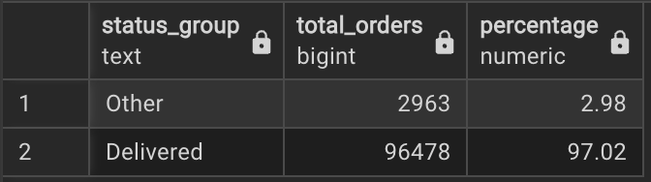
As demonstrated from the results, the query indicates a very high conversion rate, meaning that most orders are being successfully delivered by the E-Commerce company. If we would like to look at a breakdown of all orders that were NOT delivered, the code used for getting that information comprises of:
SELECT
order_status,
COUNT(order_id) AS total_orders,
ROUND(100.0 * COUNT(order_id) / SUM(COUNT(order_id)) OVER (), 2) AS percentage
FROM "Orders"
WHERE order_status != 'delivered'
GROUP BY order_status
ORDER BY total_orders DESC;

The result of the query is as follows:
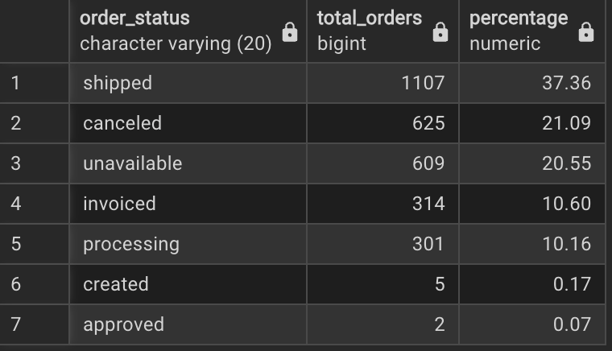
Of the number of undelivered orders, the majority were either shipped but never delivered, canceled, or made unavailable. These numbers indicate that there are still areas for improvement for the business when it comes to logistical failure with orders being not delivered or inventory issues, whenever orders become unavailable. Lastly, we would like to evaluate customer experience using the “Reviews” table by looking at the highest reviewed product categories as measured by review score. We can look at product category by reviews through this query:
SELECT
t.product_category_name_english,
ROUND(AVG(r.review_score), 2) AS avg_review_score
FROM "Reviews" r
JOIN "Orders Items" oi ON r.order_id = oi.order_id
JOIN "Products" p ON oi.product_id = p.product_id
LEFT JOIN "Translations" t ON p.product_category_name = t.product_category_name
GROUP BY t.product_category_name_english
ORDER BY avg_review_score DESC;
*Note: For viewing the lowest rated product categories change DESC to ASC from within the ORDER BY clause in the code.

The top-rated product categories:
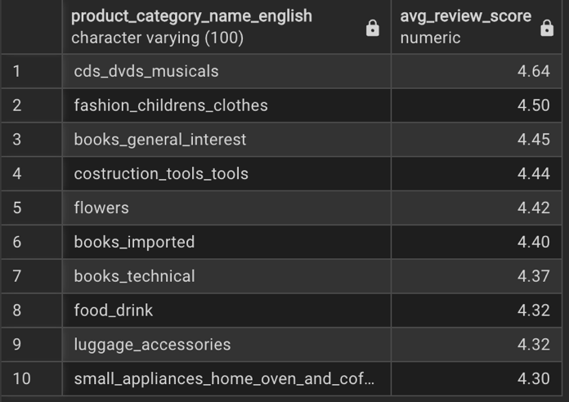
Lowest-rated product categories:
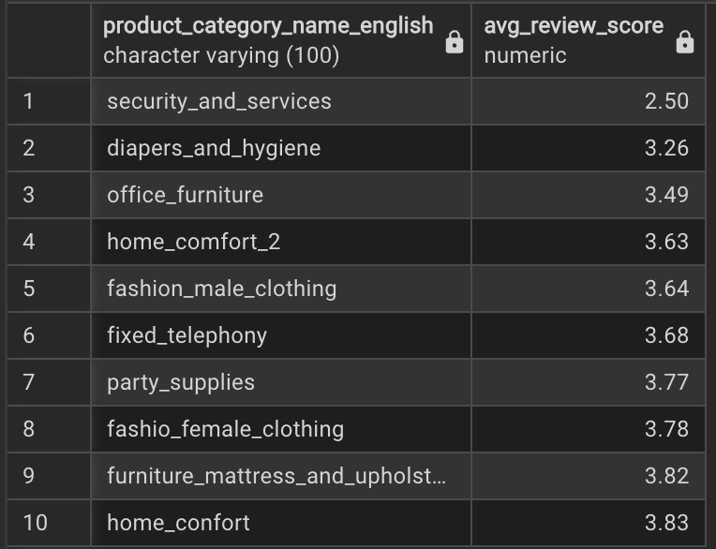
It seems that there is high satisfaction among customers for books, media-content and appliances. Meanwhile, home goods, such has home_comfort and security_and_servies tended to have lower scores. It might be useful to evaluate the e-commerce business’ relationship with suppliers for these goods to see whether the product experience for customers can be improved.
Conclusion: There is a high concentration of business activity from within Sao Paulo. However, there may be opportunities for business expansion in other geographic locations. While the overall customer experience is positive, there are still areas for improvement when it comes to logistical and inventory failure. In the last article of this series, we will finalize data story telling with a Tableau dashboard using the query outputs produced.

Brazilian E-Commerce Business Intelligence Insights Part 3: Conclusion and Final Presentation

Image URL: https://agenciaeplus.com.br/en/e-commerce-2/page/133/
Review: The previous article examined queries on customers, sellers, delivery, and product rankings. This article concludes the Brazilian e-commerce analysis with a Tableau dashboard of those queries. The Kaggle data link is below:
https://www.kaggle.com/datasets/olistbr/brazilian-ecommerce
Additionally, the GitHub link to the repository storing query results is here. Contained within the created GitHub repository is the following documentation:
- A complete transcript compiling the 3 articles on Brazilian E-Commerce.
- The “Queries” folder, which contains the results from the SQL queries made in the previous article saved as CSV files.
- The “Tableau Inputs” folder has the modified results of the queries, specifically used as the inputs for the Tableau dashboard that was created.
- Also, in the “Tableau Inputs” folder is the tableau dashboard file that can be downloaded and used in following along with this article.
Please note that installation of PGADMIN 4 and Tableau Desktop are required to successfully follow along with the demonstration. To install Postgres, PGADMIN4, and Tableau Desktop, the links are tied to the tool’s names. Instructions are prompted with installation. A companion video for the 3 articles has also been created and is posted below:
(Video Embedded in the LinkedIn Learn Article)

Furthermore, a screenshot of the Tableau Dashboard that has been created is as follows:
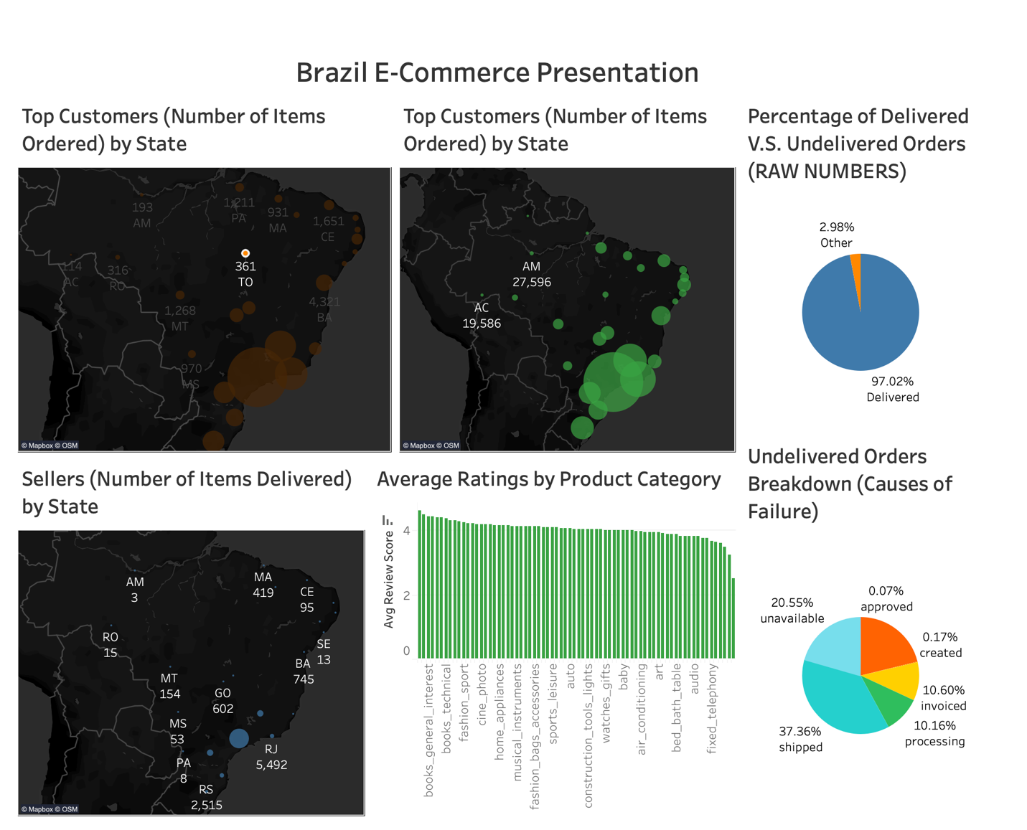
Recommendations: The business should keep investing in São Paulo and explore expansion into neighboring south-western states. Delivery performance is strong but can improve. Product ratings vary and lag competitors, so investment should favor the highest-rated categories.
Explanation: The orange-circle map at the top left and the green-circle map beside it show most orders and revenue concentrated near São Paulo, where the largest circles cluster. Those large circles also suggest sizable consumer markets in neighboring states. The bottom-left map, with small blue dots, shows sellers are also concentrated there, so expanding into neighboring states would cost less and ramp up faster than in other regions, such as the northeast or west.
Meanwhile, the top-right pie chart shows 97% of orders were delivered (blue) and just under 3% were not (orange). The bottom-right chart shows most failures came from unavailable products (light blue) and orders shipped but never delivered (teal). To improve delivery, the analysis recommends collecting supply chain data, both internal and from contractors, to reduce shipped-but-undelivered orders. It also recommends collecting supplier inventory data so stock levels better match customer demand.
Finally, the central green bar chart shows a variety of product classes rated both poorly and well, with averages slightly above 4 out of 5. Top-performing products on Amazon typically average 4.3 to 4.5. To raise average reviews, the analysis recommends promoting the highest-rated classes, such as DVDs, children’s clothing, and books (see Query 6-Product_Class_AVG_Review.csv).
Conclusion: The analysis produced sound results, but the technology was slow and outdated. The data was prepared manually in Excel, and because each query view was a separate Tableau source, the visuals couldn’t be linked. AI features could have automated many of these manual steps. The manual approach was intentional, to teach the analysis process step by step while avoiding expending CPU user credits/tokens with an AI or cloud vender. Tools like Databricks can speed this up, and the next few articles will explore them hands-on. Hopefully, this series was informative and enjoyable.

